Meme on the US Government
Students’ Name
Institution Affiliation
Date of Submission

Meme on the US Government
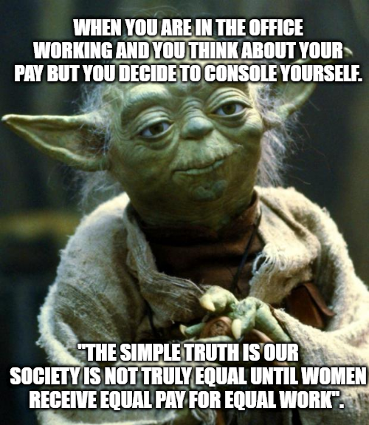
The US government is facing a great challenge in addressing the issue of equality in gender pay. After declaring that pay gap discrimination is illegal in the United States, a persistent pay gap between men and women has continued to hurt women workers and the national economy. In America, women who work full time get paid 82% of every dollar paid to men. The government has failed to implement an effective measure to end the gender pay gap in the US.
The meme above reflects the pain felt by working women. They do a lot of work, but what comes in their pockets is not worthy of what they have done at the end of the day. All this shows how our societies are shaped in such a square of arrogance. Many organizations, institutions, and private entities take advantage of such a scenario by paying women less than men. The government can end gender pay discrimination by passing strict measures to private organizations and institutions to stop pay gap inequality. By looking at the meme above, one can see how to pay gap disparity pains. The consequences of this gap discrimination affect women throughout their lives.
The inequality in gender pay can be related to an economic burden neglected by the government. The rate at which women are outpacing men, especially in acquiring higher education, is increasing. Women hold almost "two-thirds of the outstanding student debt in the United States." Because of the existing gender pay gap, they have a hard time repaying their loans. The meme expresses how someone might be thinking about her debt repayment as she compares her pay. This gender pay gap extends into retirement because they received low pay during their time when working; thus, they also receive less in their pension and social security.
Margret Bjarnadottir is one of the standing persons who are fighting for pay equality. Along with #MeToo Movement, Margret says that equalizing gender pay gap addresses fair treatment of women in our societies. Generally, reducing gender pay gap creates more room for promoting, hiring and retaining women to build them and cultivate female leaders. Also, eliminating gender pay gap fosters societal wakening and discriminations in workplace. Most of shareholders, public opinions and consumer forces converge to press for equal gender pay.

Even though the gender pay gap is not properly considered, women have to console themselves and perform at work. The quote on the meme "the simple truth is our society is not truly equal until women receive equal pay for equal work" expresses a woman's voice, especially those working full-time, to motivate themselves and build a positive attitude towards their work. The government should take full responsibility for eliminating the gender pay gap in the US to create a better society that cares for both genders.

